**#SOLVEPNP_ITERATIVE**

Rotation Vectors:

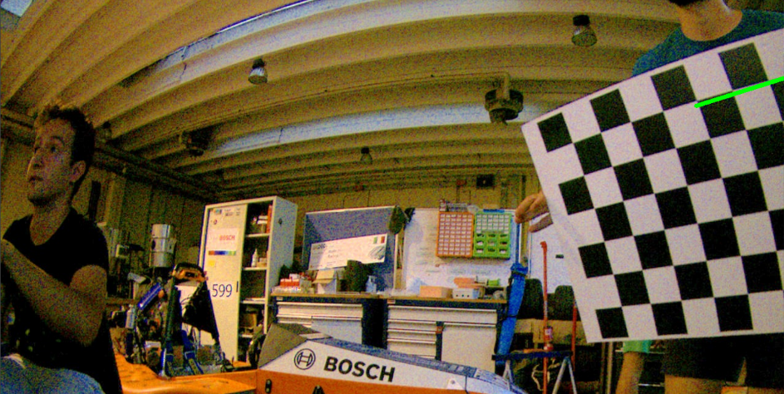[[0.78768338]

[0.54907787]

[1.19367576]]

Translation Vectors:

[[ 9.17943244]

[-3.49733341]

[10.31673547]]

**#SOLVEPNP_EPNP**

Rotation Vectors:

[[0.6539023 ]

[0.34932814]

[1.22456824]]

Translation Vectors:

[[ 9.79015111]

[-3.56694652]

[10.73703738]]

**#SOLVEPNP_IPPE**

Rotation Vectors:

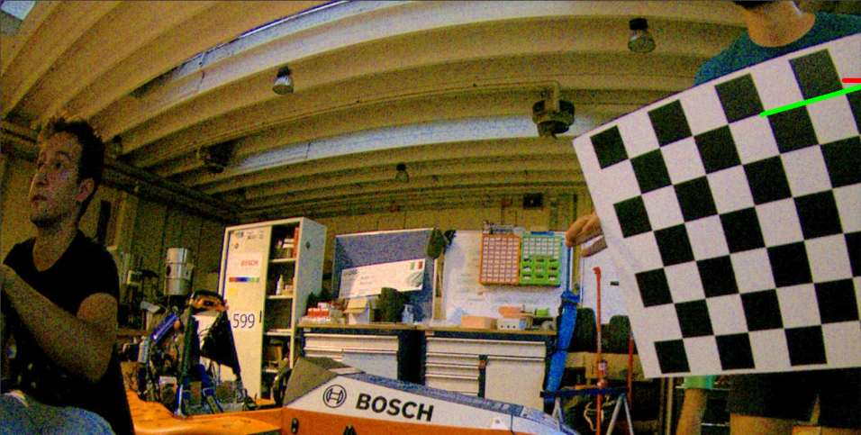[[0.86131009]

[0.60759269]

[1.16366056]]

Translation Vectors:

[[ 8.65918025]

[-3.42804881]

[ 9.75196188]]

**#SOLVEPNP_SQPNP**

Rotation Vectors:

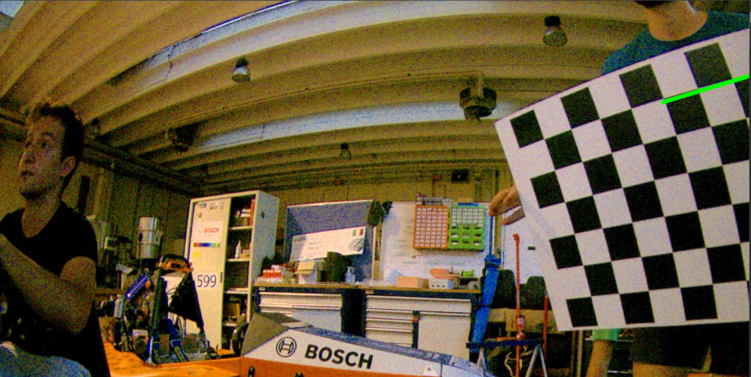[[0.79711564]

[0.54044271]

[1.18394272]]

Translation Vectors:

[[ 9.086636 ]

[-3.48682027]

[10.17002717]]

!!Doesn't work!!

#SOLVEPNP_P3P

#SOLVEPNP_DLS

#SOLVEPNP_UPNP

#SOLVEPNP_AP3P

#SOLVEPNP_IPPE_SQUARE